Simple Linear Regression
What is Regression?
- Regression analysis is a form of predictive modelling technique which investigates the relationsip between a dependent and independent variable.
- A regression shows the changes in a dependent variable on the Y axis to the changes in the explanatory variable on the X axis.
Uses of Regression:
- Determining the strength of predictors : that is the strength of the effect of the independent variable on the dependent variable. Eg: what is the strength of the relationship between sales and marketing spend or the strength of the relationship between kilometers travelled by a vehicle and its price.
- Forecasting an effect: that is forecast effects or impact of changes. That is how much the depenent variable changes with unit change in the independent variable(s).Eg: how much additional sale income will I get for each thousand dollars spent on marketing.
- Trend foecasting: In this the regression analysis predicts trends and future values. The regression analysis can be used to get Point estimates.Like for eg: what will be the price of Bitcoin in the next six months.
Types of Regressions:
- Simple Linear Regression
- Multi Linear Regression
- Logistic Regression
- Ridge Regression
- Lasso Regression
- Polynomial Regression
Linear Regression:
- Linear Regression is the easiest algorithm among the machine learning algorithms.
- It is a statistical model that attempts to show the relationship between two variables with a linear equation.
Linear Regression Selection Criteria.
Classification and Regression Capabilities.
- Regression model predict a continuous variable. Such as the sales made on a day or predict the temperature of a city
- But for classification it can be used but not efficient, because for every new data point the model needs to be recreated from scratch.
Data Quality:
- Data Quality matters. In simple linear regression the outliers can significantly disrupt the outcome of the algorithm.
Computational Complexity:
- Linear Regression is not computationally expensive as compared to the decision tree or clustering aldorithms. The order of complexity for n training example and X features usually fall in either big O of X square that is O(X²) or Big O of Xn, O(Xn)
Comprehensible and Transparent:
- Linear Regression are easily comprehensible and transparent in nature.
- They can be represented by a simple mathematical notation to anyone and can be understood very easily.
So above are some of the criteria based on which we will select Linear Regression algorithm.

Where Linear Regression can be used?
- Evaluating Trends and Sales Estimates.
Linear regression can be used in business to evaluate trends and make estimates or forcast. For eg: if a company sales has increased steadily every month for past few years then conducting a linear analysis on the sales data with monthly sales on the y axis and time on the x axis. This will give you a line that predicts the upward trends in the sale. After creating the trend line the company could use the slope of the line to forecast the sale in future months.

- Analysing the impact of price changes with linear regression
Linear regression can be used to analyse the effect of pricing on consumer behavior. If a company changes the price on certain product several times, it can record the quantity itself for each price level. And then perform a linear regression with sold quantity as the dependent variable and price as the independent variable. This would result in a line that depicts the extent to which the customer reduce their consumption of the product as the price increase.This would help us in future pricing decisions.

- Assessment of risk in financial services and insurance domain.
A health insurance company may conduct a linear regression by plotting the number of claims per customer against its age and they might discover that the old customers tend to make more health insurance claim. Such analysis might guide important business decisions.
Discussion:
Suppose you have 2 variables x and y which are independent and dependent variables plotted on a graph.

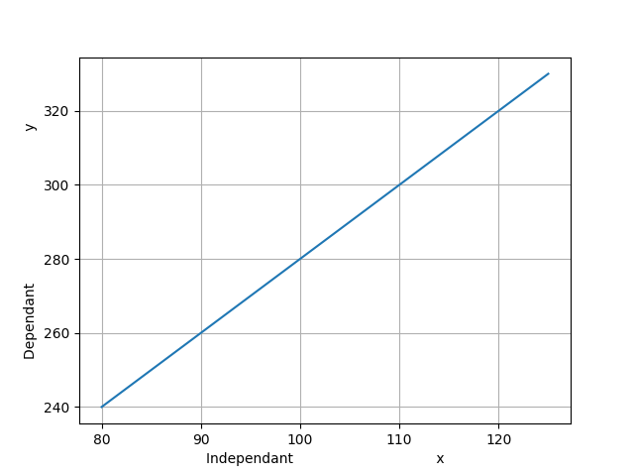
Image: Positive Linear Regression
- When the independent variable increases on the x axis, if the dependent variable also increases on the y axis, you would get a positive linear regression.
- The slope of the line will be positive.
- When the independent variable decreases, if the dependent variable decreases, then you would get a negative linear regression.
- The slope of the line will be negative.
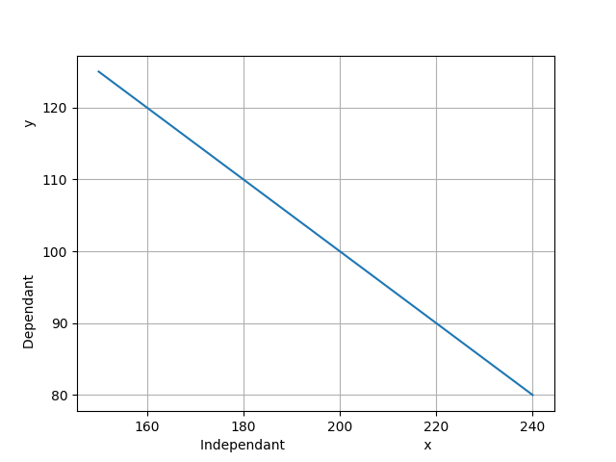
- This line of regression shows the relation between the independent and dependent variable.
- This line is represented by the equation y=mx+c

- If we have plotted some data points on the graph,
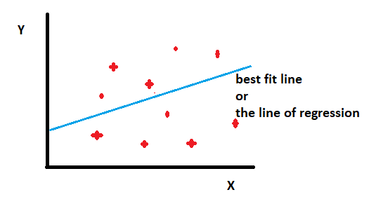
- Let us say the task is to plot the best fit line or the line of regression for these data points.
- Once our best fit line is drawn, now we have the task of prediction.
- Suppose we have an actual value and a predicted value.
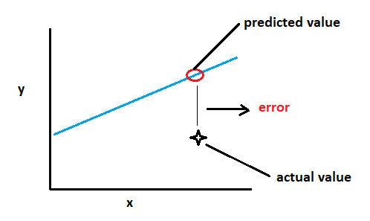

- Our main goal is to reduce the error or distance between the actual value and the predicted value.
- The best fit line is the one which has the least error or least difference between the predicted value and the actual value.
- In other words we have to minimize the error.

Mathematical implementation:
- First let us see a graph where speed is in x axis and distance is in y axis for a fixed duration of time.
- If you plot a line or a graph, then we will get a positive relationship.
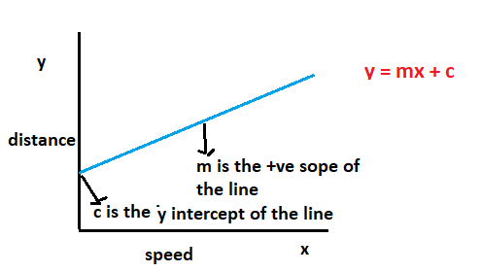
- If the equation of the line is
Y=mx+c
Where
Y is the distance travelled in a fixed duration of time
X is the speed of the vehicle
M is the positive slope of the line
C is the y intercept of the line.

- But suppose if we plot a graph between the speed of the vehicle on the x axis and time taken to travel a fixed distance, then in that case we will get a negative relationship.
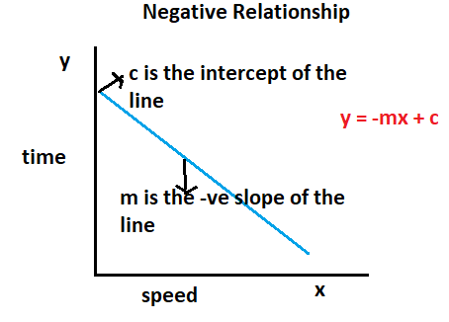
- The slope of the line is negative.
- Here the equation of the line changes to
Y=-mx + c
Where
y is the time taken to travel a fixed distance.
X is the speed of the vehicle
M is the –ve slope of the line
C is the y intercept of the line.

The mathematical implementation.
Let us consider the values of x and y as follows.
X | Y
1 | 3
2 | 4
3 | 2
4 | 4
5 | 5
Mean of x =3 | Mean of y = 3.6

Lets plot them on the X axis.
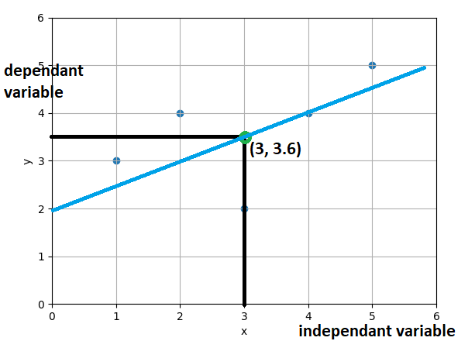

$\overline{x}=\frac{1+2+3+4+5}{5}$ = 3

$$\overline{y}=\frac{3+4+2+4+5}{5}=3.6$$

- Let us calculate the mean of x and y and plot it on the graph.
- That is let us plot the mean of x = 3 and mean of y=3.6 on the graph.
- Our goal is to find or predict the best fit line using the least square method.
- In order to find that we first need to find the equation of the line.
- Let us find the equation of the regression line.
- Suppose below given is the equation of the regression line.
Y= mx + c.

- We need to find the value of m and c.

$$m=\frac{\sum{\left(x-\overline{x}\right)(y-\overline{y})}}{{\sum{\left(x-\overline{x}\right)}}^{2}}$$

Let us calculate .

X | Y | $$x-\overline{x}$$ | $$y-\overline{y}$$
1 | 3 | -2 | -0.6
2 | 4 | -1 | 0.4
3 | 2 | 0 | -1.6
4 | 4 | 1 | 0.4
5 | 5 | 2 | 1.4
Mean of x=3 | Mean of y=3.6

- So $x-\overline{x}$ is nothing but the distance of all the points through the line y=3.
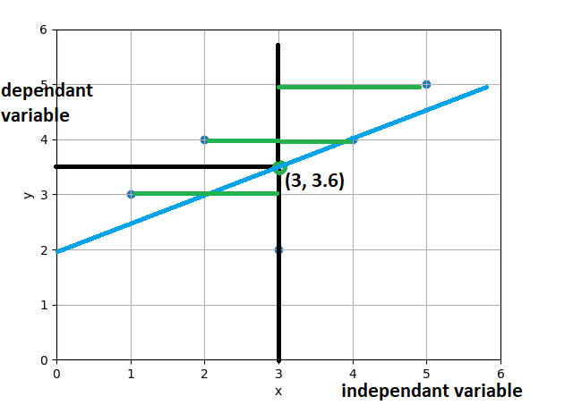

- $y-\overline{y}$ implies the distance of all the points from the line x=3.6
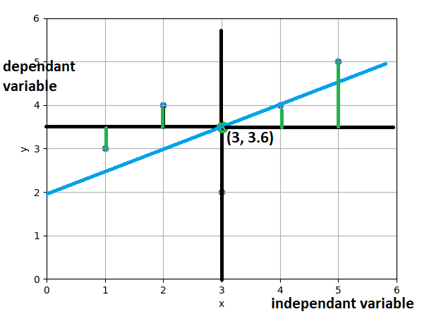
- So let us calculate the value of $y-\overline{y}$ , ${(x- \overline{x})}^{2}$ , $\left(x-\overline{x}\right)(y-\overline{y})$
X | Y | $$x-\overline{x}$$ | $$y-\overline{y}$$ | $${(x- \overline{x})}^{2}$$ | $$\left(x-\overline{x}\right)(y-\overline{y})$$
1 | 3 | -2 | -0.6 | 4 | 1.2
2 | 4 | -1 | 0.4 | 1 | -0.4
3 | 2 | 0 | -1.6 | 0 | 0
4 | 4 | 1 | 0.4 | 1 | 0.4
5 | 5 | 2 | 1.4 | 4 | 2.8
Mean of x=3 | Mean of y=3.6 |  |  | ${\sum{(x-\overline{x}})}^{2}$ = 10 | $$\sum{\left(x-\overline{x}\right)(y-\overline{y})}=4$$

- Let us get the summation of last 2 columns which is 10 and 4.
- Therefore the value of m will be
$$m=\frac{\sum{\left(x-\overline{x}\right)(y-\overline{y})}}{{\sum{(x-\overline{x}})}^{2}}= \frac{4}{10}=0.4$$

- Let us put this value of m=0.4 in our line y=mx+c
- Let us fill all the points into the equation and find the value of c.
- Mean of y is = 3.6
- m=0.4
- Mean of x = 3
- and we have the equation as
y=mx+c
that is
3.6 = 0.4 * 3 + c
3.6 – 1.2 = c
Therefore
c=2.4
So this is the regression line.
So this is how the points will be plotted
Note: m = 0.4
C = 2.4
Y=0.4x +2.4
Below are the actual points.
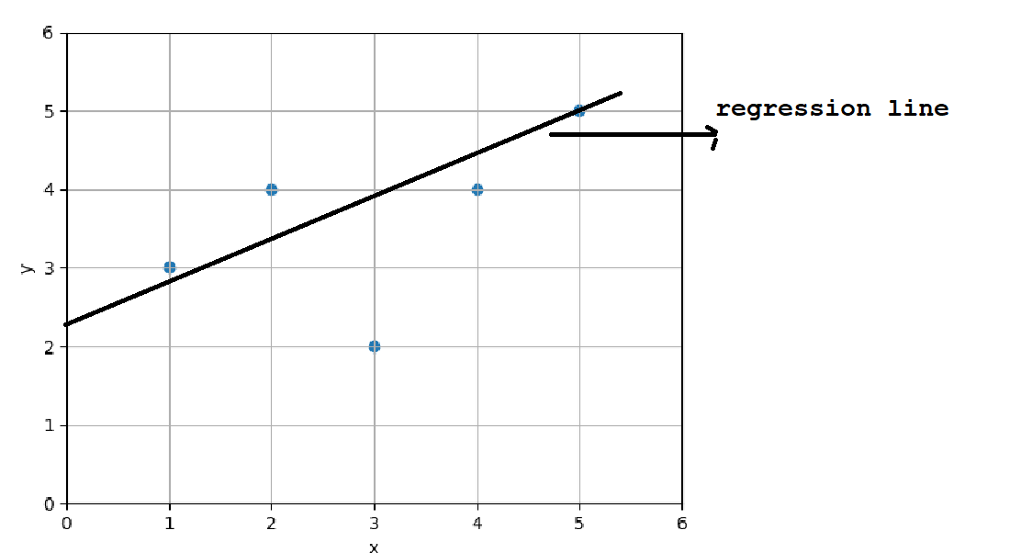
- Now for given m=0.4 and c=2.4, let us predict values for y for x=[1,2,3,4,5]

Y=0.4*1 + 2.4 = 2.8
Y=0.4*2 + 2.4 = 3.2
Y=0.4*3 + 2.4 =3.6
Y=0.4*4 + 2.4 =4.0
Y=0.4*5+2.4=4.4

- The above are all predicted y values for each x value.
- Let us plot the predicted y values for the values of x for which they were predicted.
- The line cuts the y axis at 2.4 as the line of regression.

Mean Square Error:
- The mean squared error (MSE) tells you how close a regression line is to a set of points. It does this by taking the distances from the points to the regression line (these distances are the “errors”) and squaring them. The squaring is necessary to remove any negative signs. It also gives more weight to larger differences. It’s called the mean squared error as you’re finding the average of a set of errors. The lower the MSE, the better the forecast.
MSE formula = (1/n) * Σ(actual – predicted)²
Where:
- n = number of items,
- Σ = summation notation,
- Actual = original or observed y-value,
- Forecast = y-value from regression, that is predicted value.

General steps to calculate the MSE from a set of X and Y values:
- Find the regression line.
- Insert your X values into the linear regression equation to find the new Y values (Y’).
- Subtract the new Y value from the original to get the error.
- Square the errors.
- Add up the errors (the Σ in the formula is summation notation).
- Find the mean.

x | y | yp | Error (y-yp) | Error Squared
1 | 3 | 2.8 | 0.2 | 0.04
2 | 4 | 3.2 | 0.8 | 0.64
3 | 2 | 3.6 | -1.6 | 2.56
4 | 4 | 4 | 0 | 0
5 | 5 | 4.4 | 0.6 | 0.36
 |  |  |  | Sum of errors=3.6
 |  |  |  | Mean of Squared Error=0.72

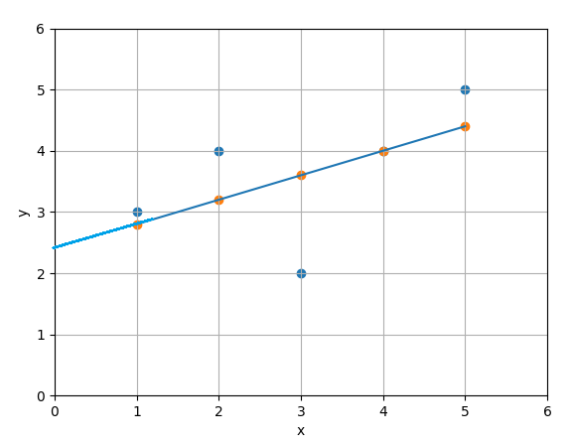
- Now our task is to calculate the distance between the actual and predicted values.
- And our job is to reduce the distance, or in other words you have to reduce the error between the actual and the predicted values.
- The line with the least error will be the line of linear regression or regression line and it will also be the best fit line.
- So below is how different regression lines are created.
Iteration=1 iteration=2 iteration=3
M=0.04 m=0.07 m=0.11
B=0.0 b=0.00 b=0.00
Y=0.04x *0.00 Y=0.07x *0.00 Y=0.11x *0.00
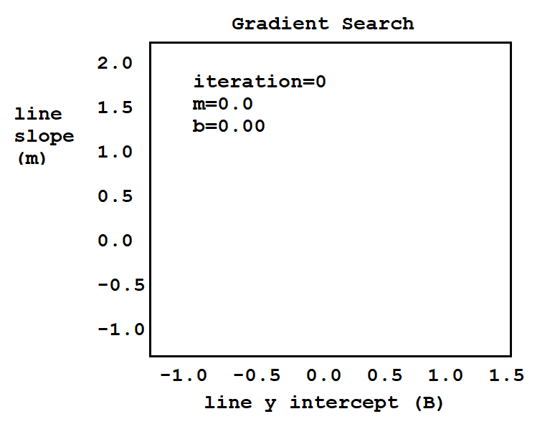

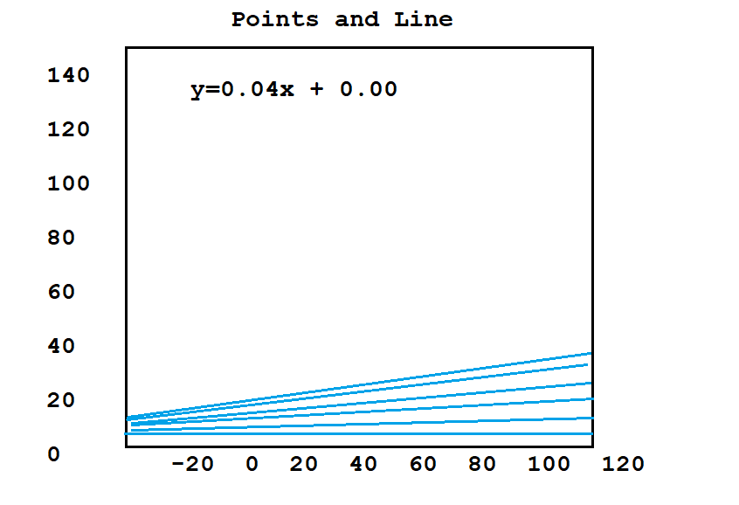
- We performs n number of iterations for different values of m.For different values of m, it will calculate the equation of the line where y=mx+c
- As the value of m changes the line is changing.
- The iteration will start from 1.
- And it will perform a number of iterations.
- So after every iteration, it will calculate the predicted value of m for which the distance between the actual and the predicted value is minimum.
- That line will be selected as the best fit line.
- Now that we have calculated the best fit line, now it is time to check how good our model is performing.
- In order to do that we have a method called the R-Squared method.

What is R-Squared Method?
- R-Squared value is a statistical measure of how close the data are to the fitted regression line.
- It is also known as the coefficient of determination or coefficient of multiple determination for multiple regression.
- 1(100%) is the best score and 0(0%) is worst score..

- In general it is considered that a high R-Squared value model is a good model. But you can also have a lower R-Squared value for a good model as well.
Calculation of R²:
- Let us see how a R-Squared value is calculated.
- Below are the actual values plotted on the graph.
X | y
1 | 3
2 | 4
3 | 2
4 | 4
5 | 5

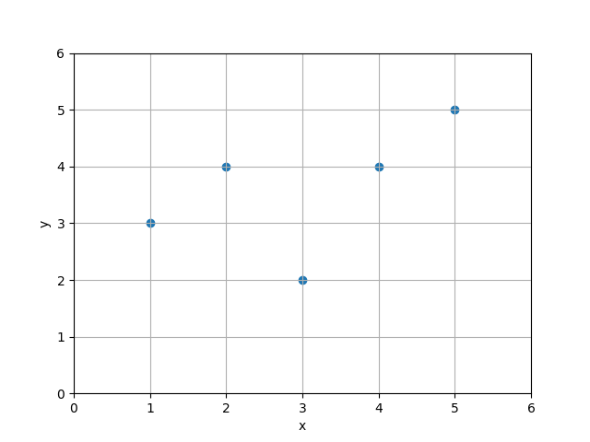

- We had calculated the predicted values.
X | y_{p}
1 | 2.8
2 | 3.2
3 | 3.6
4 | 4.0
5 | 4.4

- The regression line was as follows.
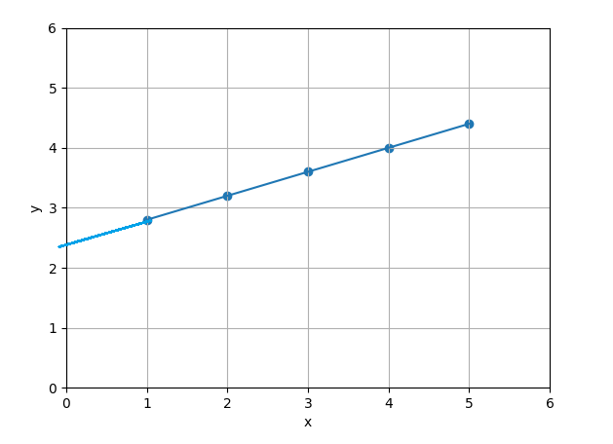

- We had calculated the predicted values of y for the equation
Y_{p} = 0.14x + 2.4
for every x=[1,2,3,4,5]
- From there we got the predicted values of y.
That is y_{p} = [2.8, 3.2, 3.6, 4.0, 4.4]

- Let us plot it on the above graph.
- So these are the points and line passing through these points are nothing but the regression line.

- Now we need to check and compare the distance of actual – mean versus the distance of predicted – mean.
That is
Distance actual - mean
Vs
Distance predicted – mean

This is nothing but $R^{2}= \frac{\sum{{(yp- \overline{y})}^{2}}}{\sum{{(y- \overline{y})}^{2}}}$

- Here we are calculating the distance of actual value to the mean to the distance of the predicted value to the mean.

- In the equation y is the actual value and y_{p} is the predicted value and $\overline{y}$ is the mean value of y, that is nothing but 3.6.
- Let us calculate y - $\overline{y}$

x | y | y - $\overline{y}$ | (y - $\overline{y}$) ² | y_{p} | y_{p} - $\overline{y}$ | (y_{p} - $\overline{y}$) ²
1 | 3 | -0.6 | 0.36 | 2.8 | -0.8 | 0.64
2 | 4 | 0.4 | 0.16 | 3.2 | -0.4 | 0.16
3 | 2 | -1.6 | 2.54 | 3.6 | 0 | 0
4 | 4 | 0.4 | 0.16 | 4.0 | 0.4 | 0.16
5 | 5 | 1.4 | 1.96 | 4.4 | 0.8 | 0.64
 | Mean $\overline{y}=3.6$ |  | $$\sum{}=5.2$$ |  |  | $$\sum{}=1.6$$

$$\sum{{(y-\overline{y})}^{2}=5.2}$$
$$\sum{{(yp-\overline{y})}^{2}=1.6}$$

So $R^{2}= \frac{\sum{{(yp- \overline{y})}^{2}}}{\sum{{(y- \overline{y})}^{2}}} = \frac{1.6}{5.2}$

- So R² is approximately equal to 0.3
- This is not a good fit.
- It suggests that the data points are far away from the regression line.
- So the above graph is how it will look like when R square is 0.3.

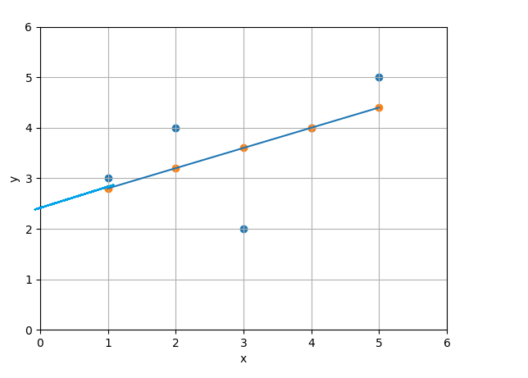

- When you increase the value of R² to 0.7, you will see that the actual value would be closer to the regression line.
- When it reaches 0.9, it comes more closer and when the value is approximately equals to 1, then the actual values lies on the regression line itself.
- For example, if you get a very low value of R square as 0.02, in that case what we will see the actual values are very far away from the regression line or you can say that there are too many outliers in your data. You cannot forecast anything from the data.

